CITY OF CALIMESA

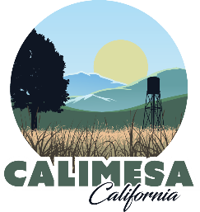

NOTICE of public hearing

public NOTICE IS HEREBY GIVEN that on April 13, 2026 at 6:00 p.m. in the Norton Younglove Senior Center, 908 Park Avenue, Calimesa, California, the Planning Commission of the City of Calimesa will hold a public hearing (in person) to consider the proposed development project as follows:

DPR 24-04: AN APPLICATION HAS BEEN SUBMITTED ON BEHALF OF TRACTOR SUPPLY COMPANY FOR A PROPOSED 1,848 SQUARE FOOT ADDITION AND INTERIOR REMODEL TO THE EXISTING 18,800 SQUARE FOOT COMMERCIAL BUILDING LOCATED AT 1060 CALIMESA BLVD., CALIMESA, CA 92320 (APN: 411-100-013) IN THE CITY’S DOWNTOWN VILLAGE COMMERCIAL ZONE. THE PLANNING COMMISSION WILL CONSIDER APPROVAL OF THE PROJECT AND ADOPTION OF A DETERMINATION THAT THE PROJECT IS CATEGORICALLY EXEMPT FROM THE CALIFORNIA ENVIRONMENTAL QUALITY ACT (CEQA) GUIDELINES PURSUANT TO SECTION 15301(C) – EXISTING FACILITIES.

NOTICE IS FURTHER GIVEN that the public may provide comments as follows: 1) Submit written comments to City Hall at the above address, 2) Email comments to the Deputy City Clerk at ybenson@calimesa.gov, or 3) Attend the meeting in person and speak thereon. Please note, mailed and/or emailed comments must be submitted by 5:30 p.m. on April 13, 2026.

PLEASE NOTE that pursuant to Government Code Section 65090, if you challenge the project in court, you may be limited to raising only those issues you raised at the public hearing as described in this Notice or in written correspondence delivered to the City Clerk of the City of Calimesa prior to or at the public hearing.

CITY OF CALIMESA

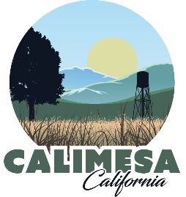

Project vicinity

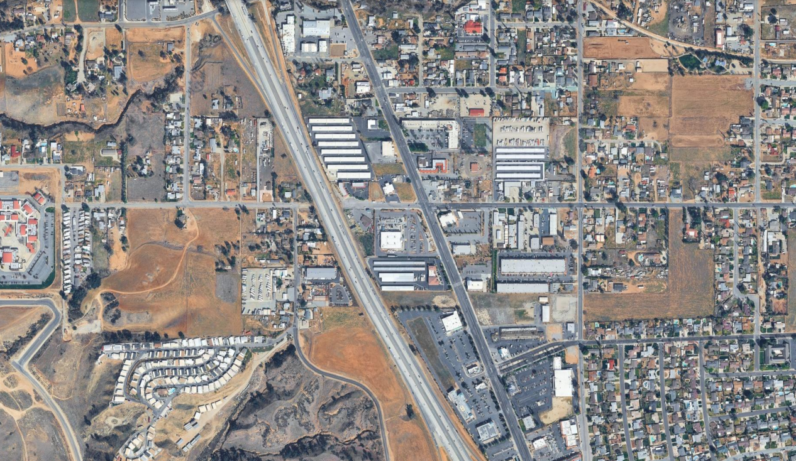
PROJECT SITE

